

**ID**: 2019-1-60-028

2019-1-60-038

2019-1-60-039

**Course Instructor:** Md. Mohsin Uddin

Abstract

A Brief Outlook of the main working principles of the project application

PATIENT APPOINTMENT SYSTEM

A Project of CSE103 Submitted by Sumit, Ishrat and Nabila

# **Project Proposal**

**Patient Appointment System**

Functionality:

* + - User can book their appointment to doctors of a hospital using the system.
    - They can insert
      1. Their personal details.
      2. Select doctor from the given list.
      3. Select schedule etc.
* Also they have the rights to delete and update appointment.
* Also user can have the rights to gain a file output of their appointment from the system.

**Significance**

Life is becoming too busy to get medical appointments in person and to maintain a proper health care. The main idea of this work is to provide ease and comfort to patients while taking appointment from doctors and it also resolves the problems that the patients has to face while making an appointment. If anybody is ill and wants to visit a doctor for checkup, he or she needs to visit the hospital and waits until the doctor is available. The patient also waits in a queue while getting appointment. In this situation, the need for a computerized patient appointment system arises.

The Patient Appointment Application provides a detailed appointment with the preferred doctor according to the User choice. The User can put in their personal details and even select the suitable date and time slot for the appointment. It even provides the User with an opportunity to update a previously made appointment. A written file record of the appointment is also handed out to the User according to necessity. The User can even cancel their appointments if they want.

The whole project acts as a replacement for the previously hand written approach to the system and saves time as well as human labor.

**User Manual**

# Precautions:

1. Close other apps for best performance.
2. App Data should not be altered.
3. Input of name should be a string without using any spaces.

# Instructions:

1. In home screen, press any key in the keyboard to proceed.

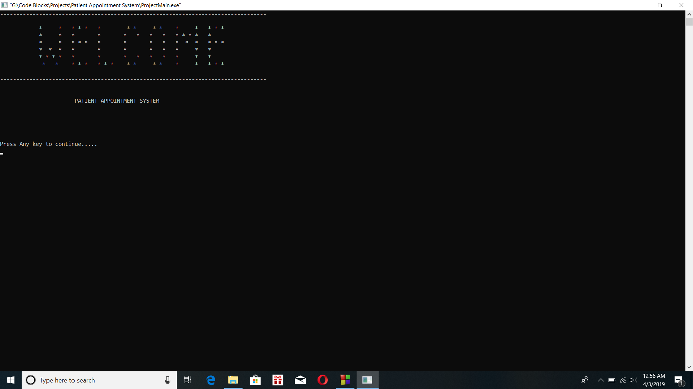

1. Enter integer numbers as choices for the main menu and other menus.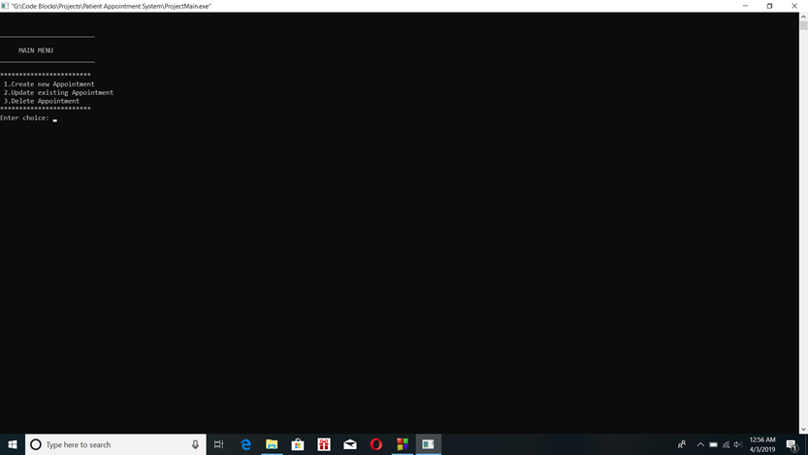
2. Enter Details of the patient in the Personal Details screen.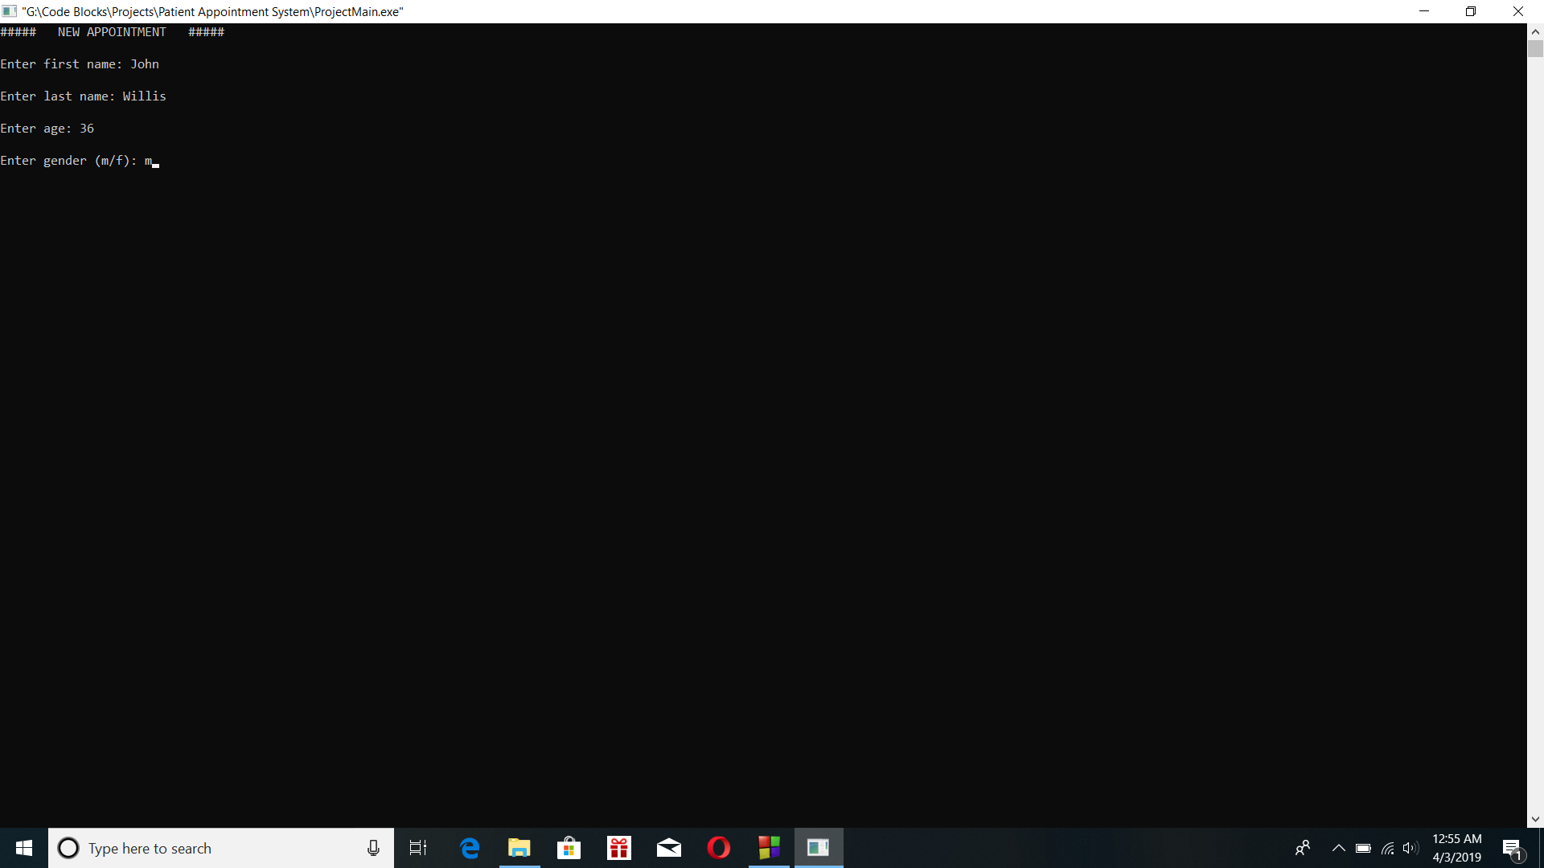
3. Select the preferred doctor according to the details.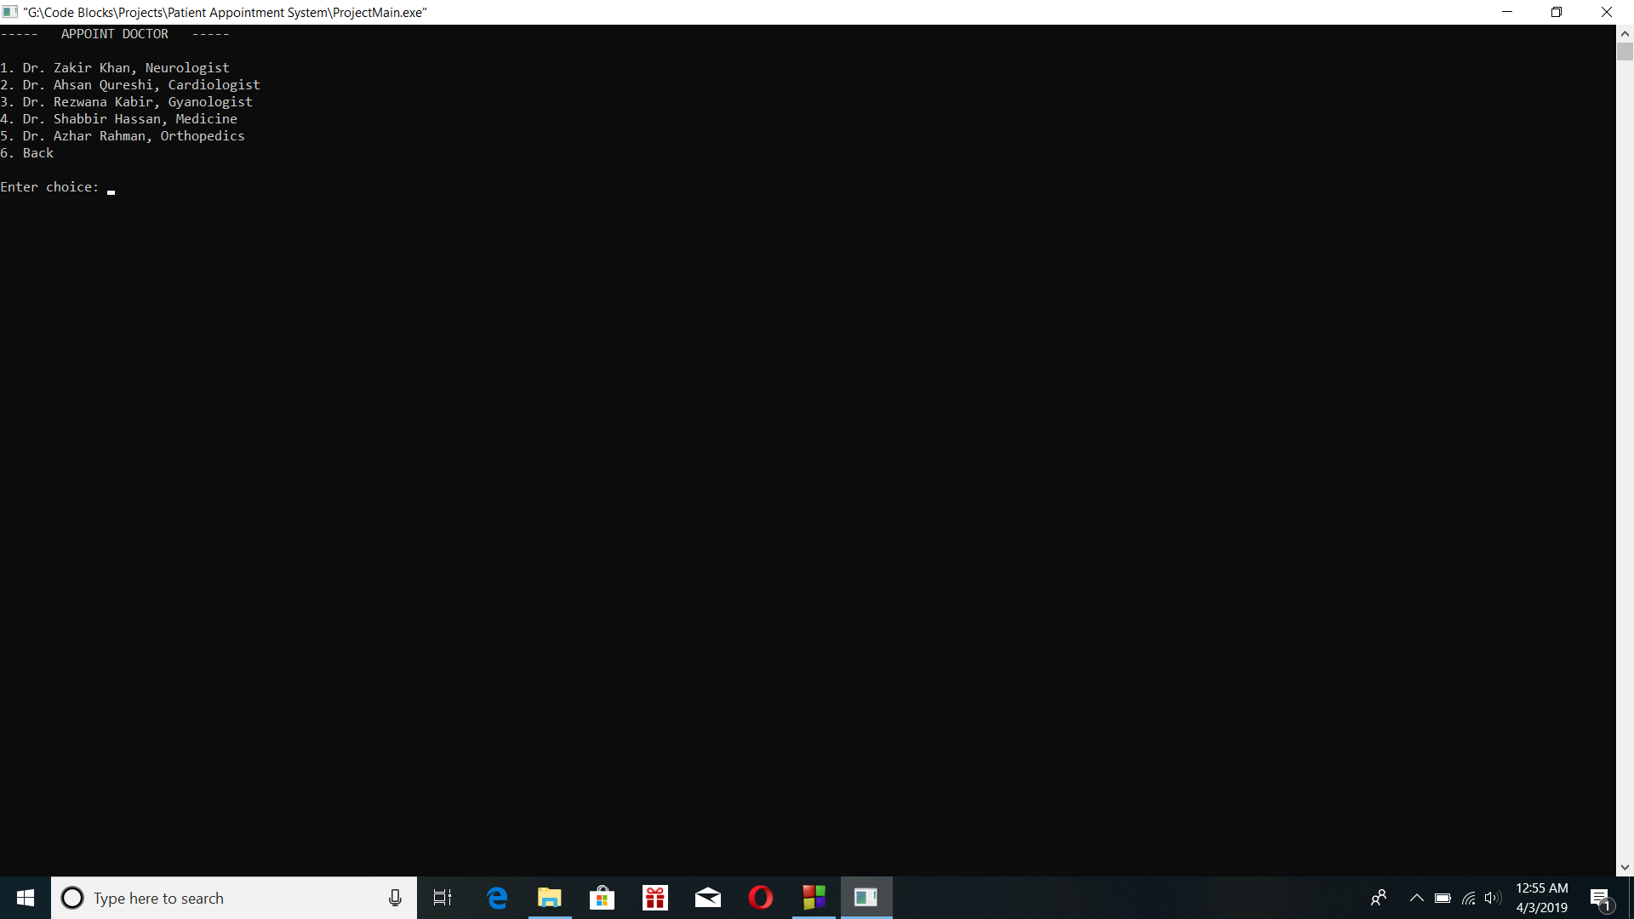
4. Select the preferred date and slot for the appointment.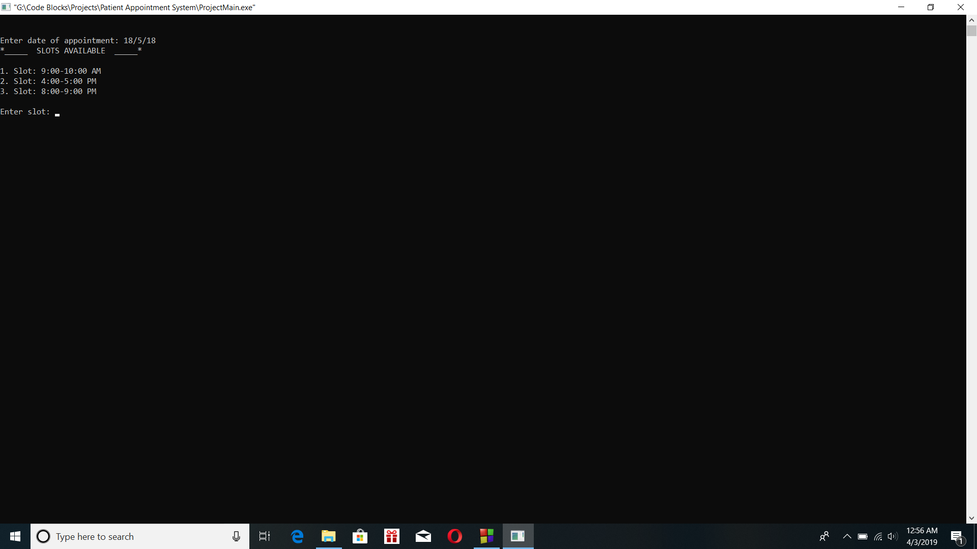
5. According to choice, get a file output of the detailed appointment as a text file.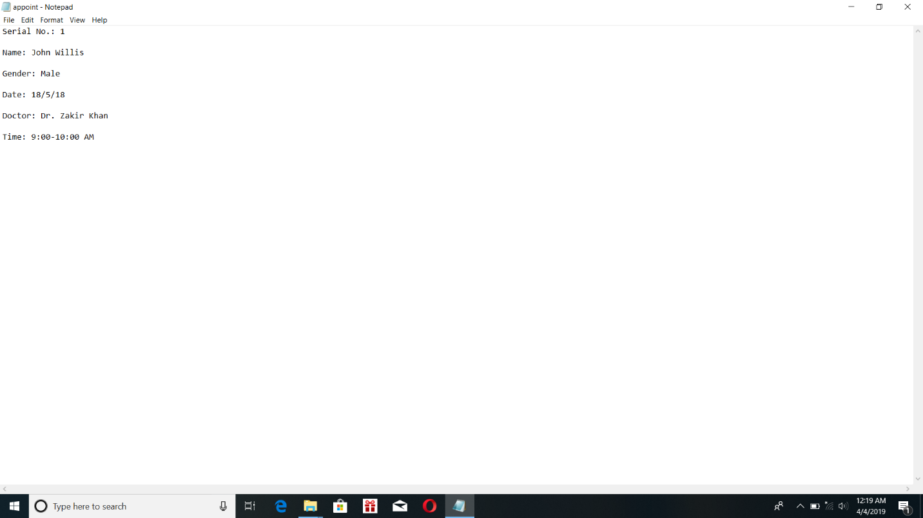
6. Continue to set further appointments.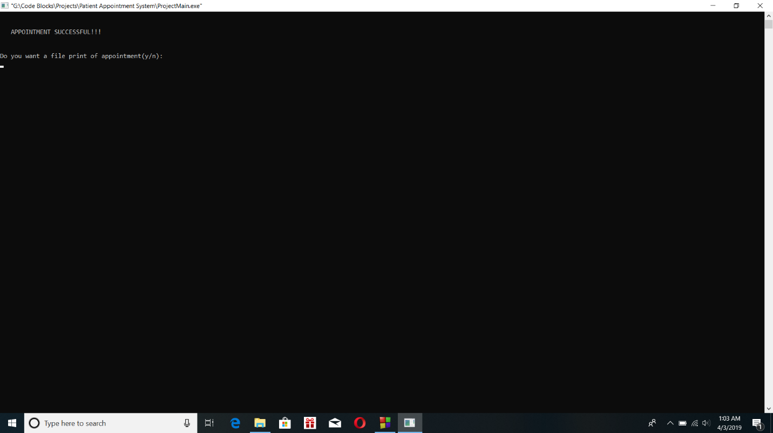
7. In case of update, chose details to be updated and get the updated appointment.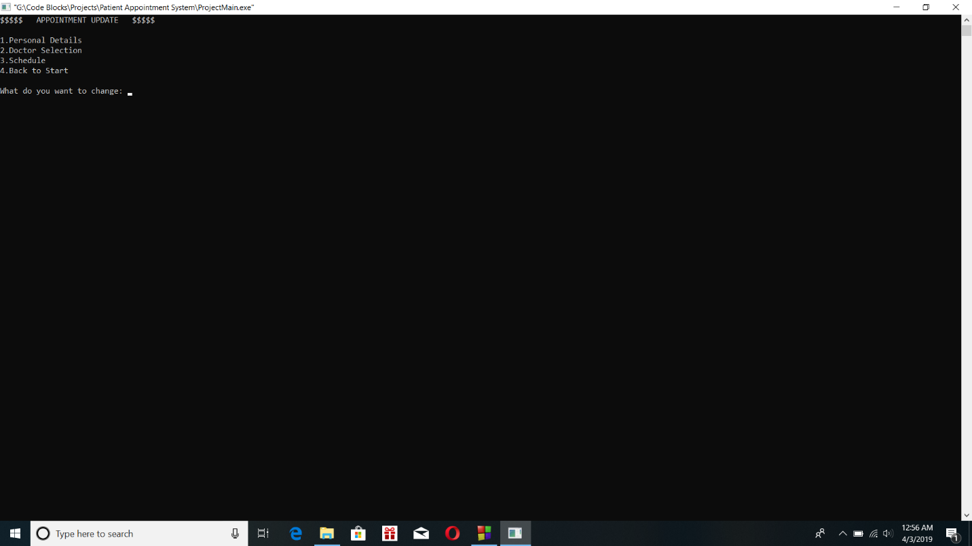
8. For Removal of appointment, delete the appointment according to the serial number.
9. Close the app if appointments are done for the day.

# **Working Principle**

For the execution of the program, a number of User Defined functions are used. Which are:

**1. PrsnlDetails()**

**2. DocSec()**

**3. Schd()**

**4. Update()**

**5. Delete()**

**6. FilePrint()**

In addition to that, a Structure is also used and it is named **ptn.**

All of these functions and the structure is written in a separate header file named **UDfuncs.h .** In the main source code named **ProjectMain.c ,** this header file is included giving it access to all those user defined functions. In addition to that, other header files included are stdio.h, stdlib.h and string.h.

In the main function, at first we print a home screen to welcome the user and proceed to the next screen. The next screen is the Main Menu and we print the 3 choices for execution which are Create New Appointment, Update Existing Appointment and Cancel Appointment. Then, we ask the user for the choice and the entered choice is put into a switch case.

If the user selects Choice 1, then at first the PrsnlDetails() function is called. The function allows the user to enter their personal details like Name, Age and Gender. Then the DocSec() function is called which allows the user to select their desired doctor. After that, the Schd() function lets the user to select the date and time slot for their appointment. All of these information is stored as the properties of the structure variable. A message indicating Successful Appointment is displayed on the screen and the user is asked if they want a file document of the appointment. If ‘y’ is pressed then the FilePrint() function is called and all details of the appointment are printed in the text file **appoint.txt .** The user can afterwards continue the program if they want.

If the user selects Choice 2, then it asks the serial number of the appointment to be updated. After that, the Update() function is called. Through it, the user is allowed to select the kind of details they want to change. The user choice is put into switch case and the required function is called accordingly. After successful update, a message is displayed and the user may again get a file document of the updated appointment according to choice.

If the user selects Choice 3, then the serial number of the appointment to be deleted is asked at first. After that, the Delete() function is called. It sets all the properties of the concerned structure variable to default value. A message is then displayed indicating that the appointment was cancelled. The user may continue the program if they want.

The whole process is put into a while loop and the program may be repeated as many times as the user wants.

**Dummy Outputs**

**Home Screen**



**Main Menu**

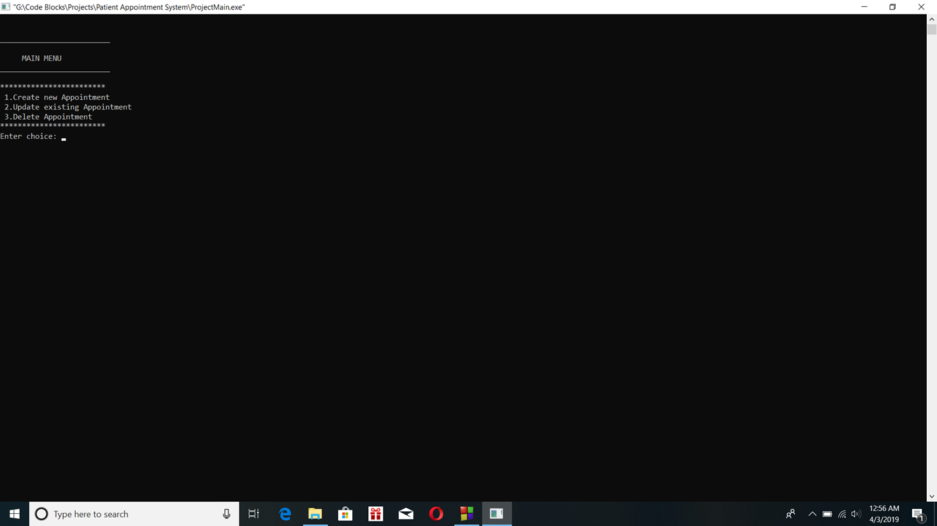

**Personal Details (For New or Update Appointment)**

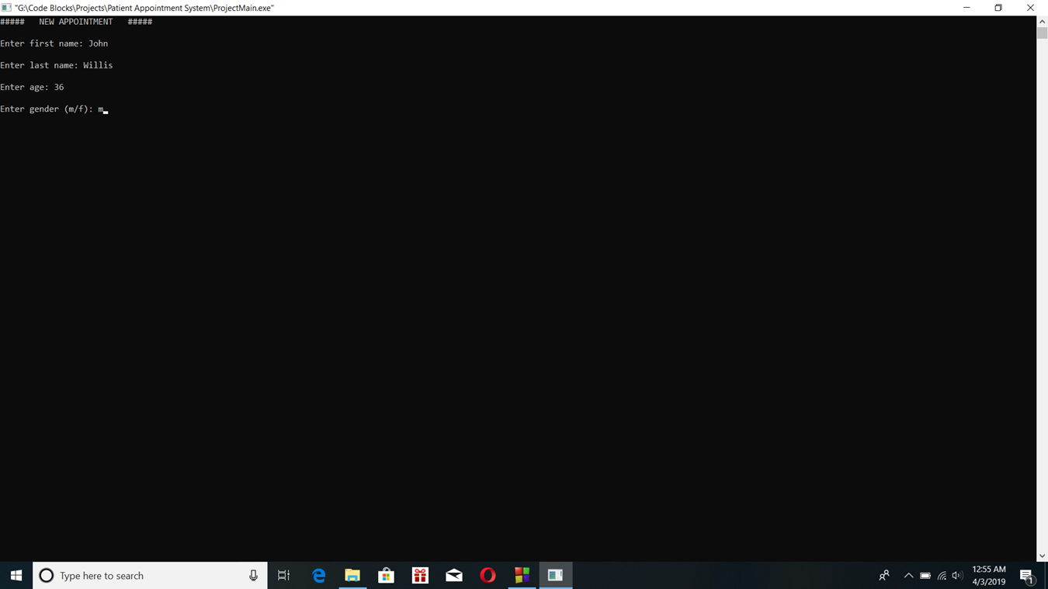

**Doctor Appoint (For New or Update Appointment)**



**Slots (For New or Updated Appointment)**



**Successful Appointment**

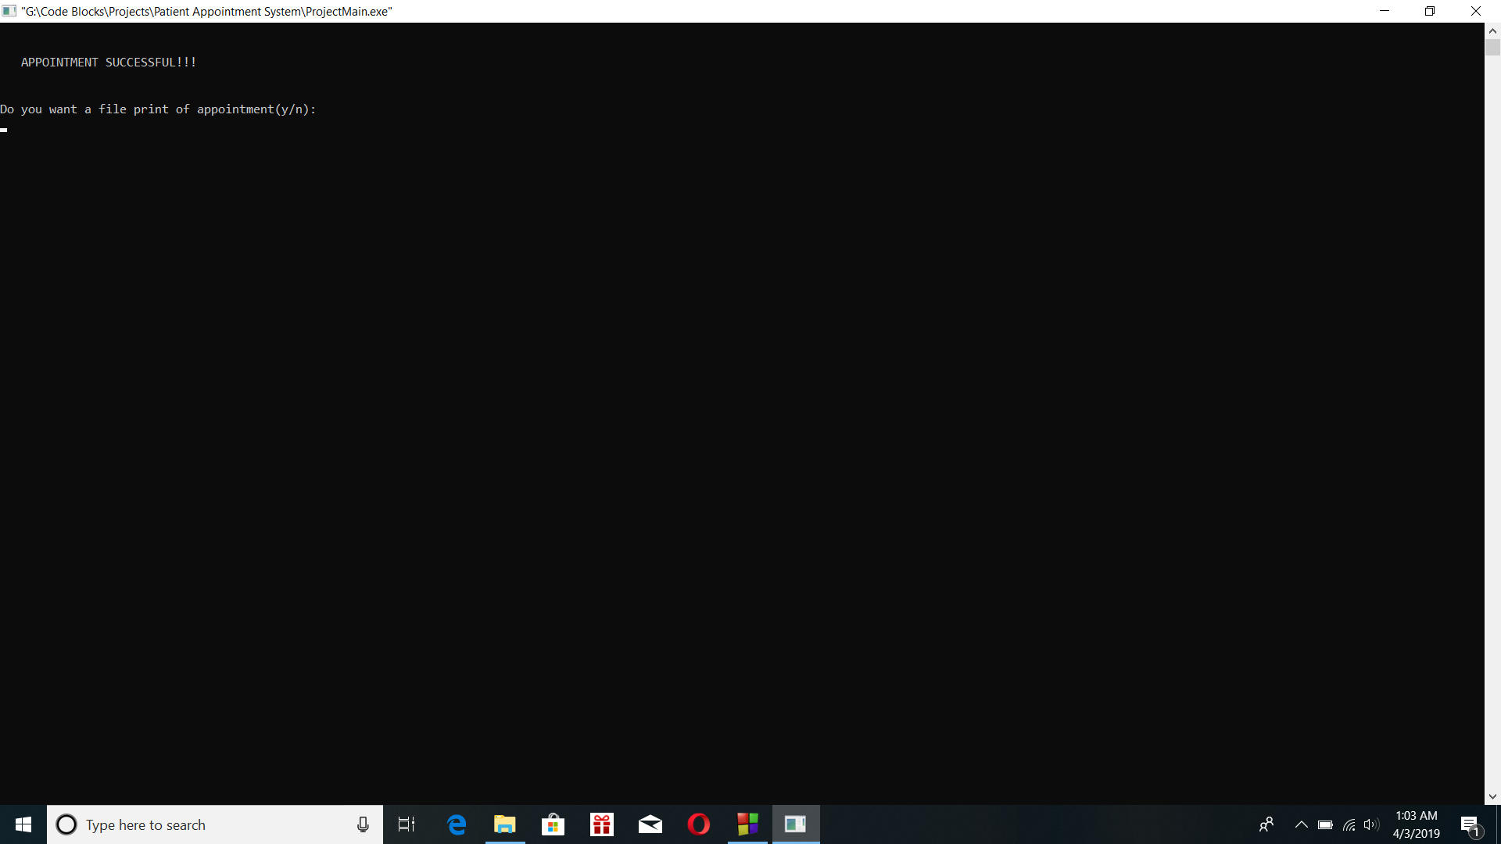

**Update Menu**

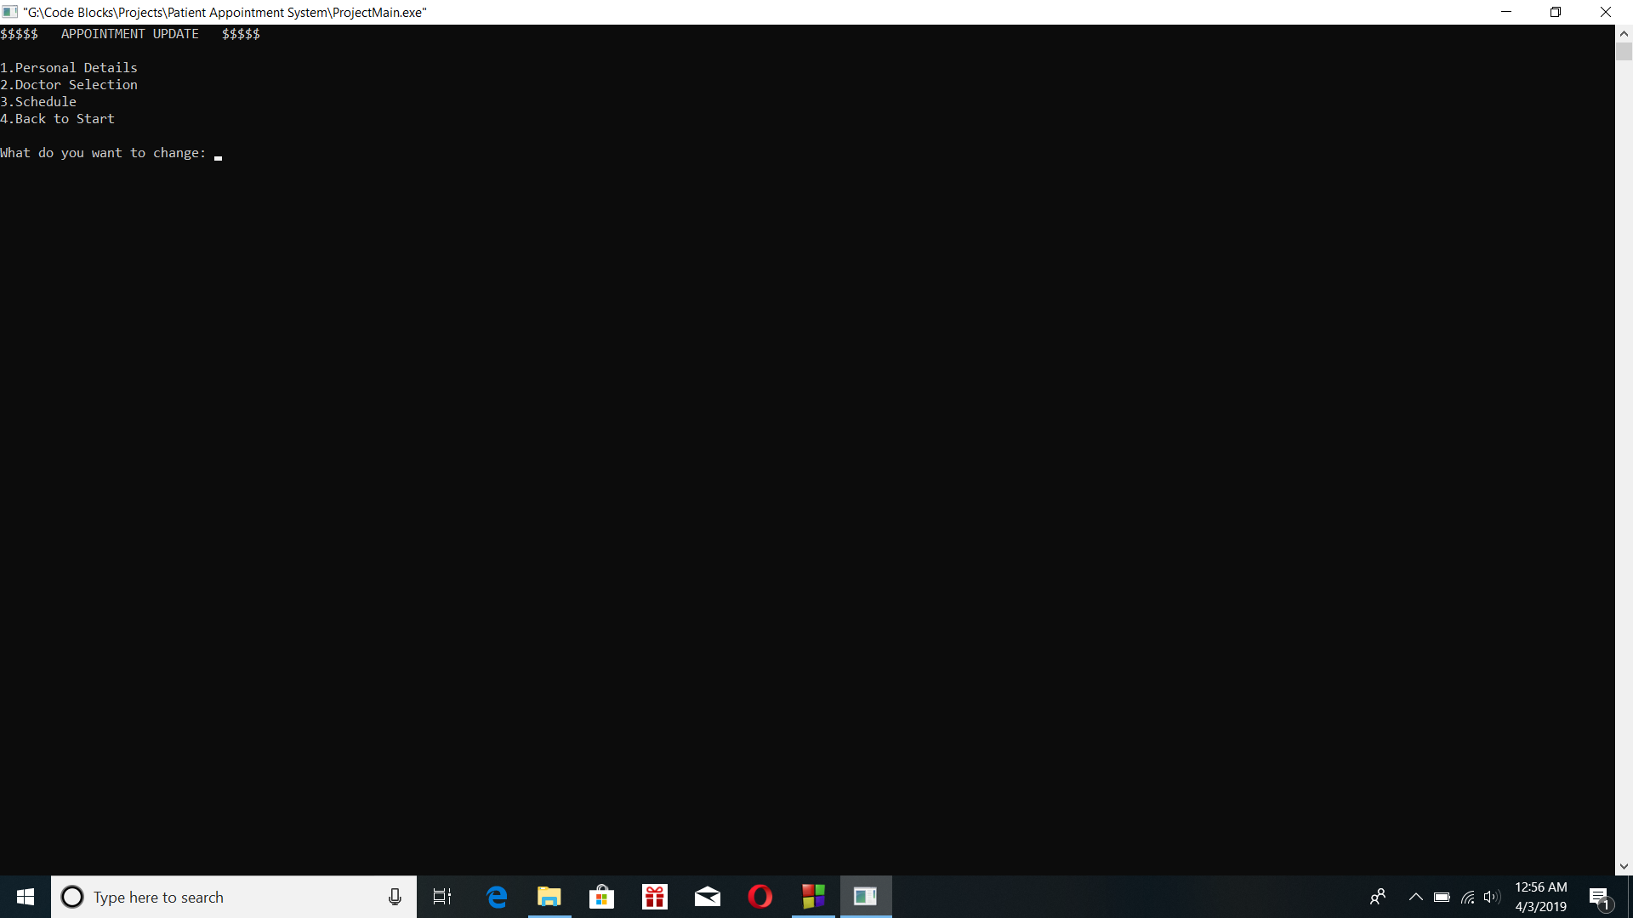

**Update Success**

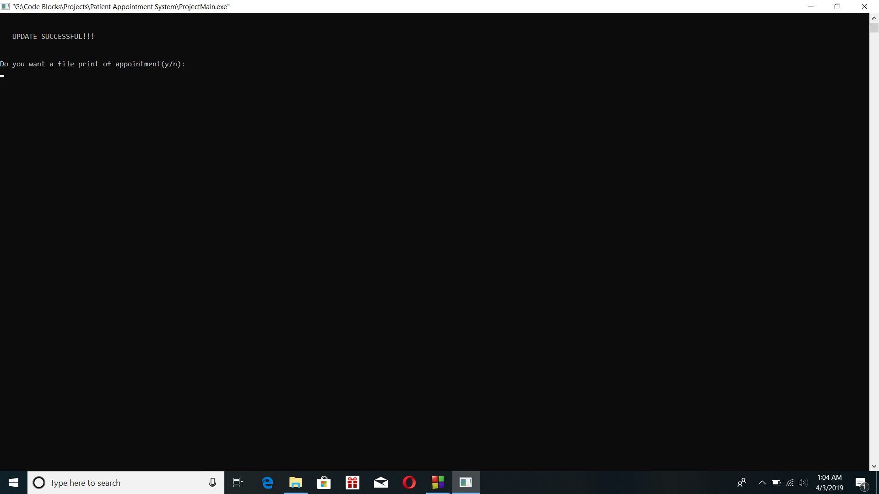

**File Output**

